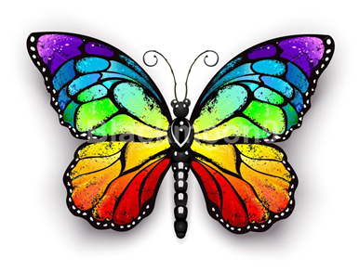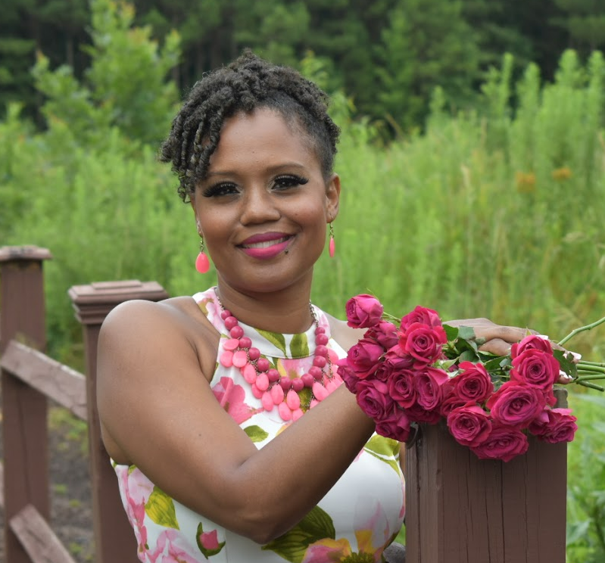 

Dear Parents,

Welcome to Burton’s Beautiful Butterflies Classroom!

My name is Mrs. Tia Burton, and I look forward to working with you and your child this school year. I am honored to have your child in my class, and I want you to know that I am going to do everything that will be in your child’s best interest to help him or her perform well socially, emotionally, and academically.

This year I am Freedom Park School’s Teacher of the Year. I currently hold a Bachelor of Science degree in Early Childhood Education from Georgia Southern University, a Masters of Curriculum Instruction and Technology from Nova Southeastern University, a Reading Endorsement, and a New Leaders Institute’s Leading Instruction certificate. I have taught kindergarten, second grade, and I am now teaching third grade English Language Arts or ELA. This is my 20th year teaching, and my ongoing professional goal is to positively impact students through education.

There are many interesting things about me. I love inspirational books and movies, drinking coffee, word puzzles, and spending time with my husband Shawn, daughter Liana, son Ethan as well as visiting with my extended family. We look forward to watching our children learn and grow throughout the years!

I thank you for your time and assistance in advance for working cooperatively with me as we travel on this journey through third grade together. I look forward to the opportunity to work with your child as well. Please feel welcome to contact me via phone at 706-796-8428 (school) or e-mail burtoti@boe.richmond.k12.ga.us, and I will respond back to you at my earliest convenience.

Sincerely,

Mrs. Tia Burton